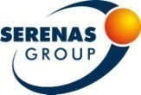
Current Issues on Diagnostic Pathology
1st Meeting of the Turkish Division of the International Academy of Pathology (IAP)
June 7-8, 2014

Elite World Hotel Istanbul / Turkey
REGISTRATION FORM

Serenas Tourism is the official agent for the Current Issues on Diagnostic Pathology Meeting to be held in Istanbul, Turkey. Please complete this form and return it to Serenas Tourism. All communications should be done with Serenas Tourism.

IDENTIFICATION
Title: Mr. Ms. Prof. Dr.
Family Name: First Name: Middle Name:
Academic Title:
Certified Specialty or Professional Sector:

Mailing Address:
City State/Country Zip/Postal Code
Telephone: Country Code City Code Number
Fax: Country Code City Code Number
E-mail Address:

REGISTRATION

Category | Early Registration  Before May 10, 2014 | Late Registration  After May 10, 2014
Specialist | 200 EUR | 250 EUR
Resident | 100 EUR | 150 EUR

- At the end of the course certificate will be given.
- All rates are in Euro and VAT 18% is not included.

HOTEL ACCOMMODATION
GERMİR PALAS HOTEL****  http://www.germirpalas.com/ |  |  | Single Room | Double Room*
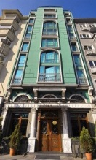 | Available within 6-8  June 2014 | 8 minutes’ walk | 80 Euro | 100 Euro
GOLDEN AGE HOTEL****  http://www.goldenagehotel.com/ |  |  | Single Room | Double Room*
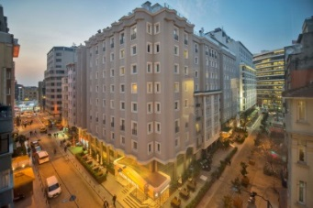 | Available within 6-8  June 2014 | 5 minutes’ walk | 100 Euro | 110 Euro
LARES PARK HOTEL****  http://www.laresparktaksim.com/default-tr.html |  |  | Single Room | Double Room*
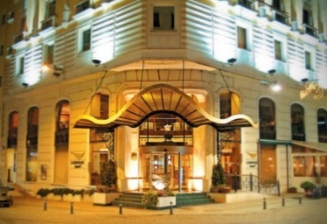 | Available within 6-8  June 2014 | 5 minutes’ walk | 160Euro | 180 Euro
LAMARTINE HOTEL****  http://www.lamartinehotel.com/ |  |  | Single Room | Double Room*
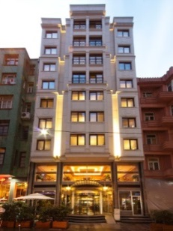 | Available within 6-8  June 2014 | 8 minutes’ walk | 130 Euro | 140 Euro
MIDTOWN HOTEL****  http://www.midtown-hotel.com/tr/hosgeldiniz_1.html |  |  | Single Room | Double Room*
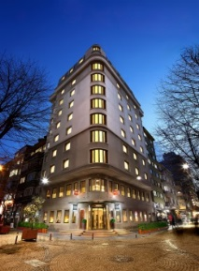 | Available within 6-8  June 2014 | 7 minutes’ drive  7 minutes’ walk | 150 Euro | 170 Euro
FERONYA HOTEL****  http://www.feronya.com/ |  |  | Single Room | Double Room*
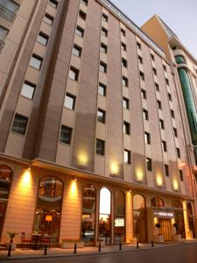 | Available within 6-8  June 2014 | 3 minutes’ walk | 80 Euro | 100 Euro
ELITE WORLD PRESTIGE HOTEL****  http://www.eliteworldprestige.com.tr/default-tr.html |  |  | Single Room | Double Room*
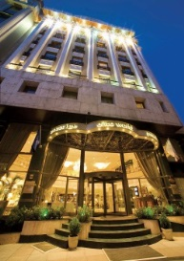 | Available within 6-8  June 2014 | 3 minutes’ walk | 120 Euro | 130 Euro

ELITE WORLD ISTANBUL HOTEL*****  http://www.eliteworldistanbul.com.tr/default-tr.html |  |  | Single Room | Double Room*
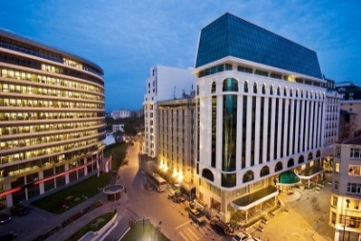 | Available within 6-8  June 2014 | - | 180 Euro | 200 Euro

- Above pricelist is given in EUR, per night.
- The price includes a breakfast, VAT 8% is not included.
- All reservations are to be made directly through Serenas Tourism for these prices.
- Before sending your form, please check the availability of your selected hotel with Serenas Tourism. Hotel confirmation will be sent to you according to availability. If the hotels are fully booked, Serenas Tourism will send you an information e-mail to select another hotel option.
- Hotel reservation will be finally confirmed when payment of the 100% for the ordered services is made not later than 10.05.2014.
- Sending a reservation form after 10.05.2014 clients will be suggested any rooms that left with individual renegotiated reservation terms.

PAYMENT

Registration Fee: Euro
VAT of Registration 18%: Euro

Accomodation Fee: Euro
VAT of Registration 8%: Euro

TOTAL: Euro

CREDIT CARD

I hereby authorize SERENAS Tourism (Serenas Uluslararası Turizm Kongre Org. A.Ş.) to have my credit card charged for the amount of Euro, which has the details below.

Type of Credit Card: Visa Master Card
Card holder’s name:
Card number*: / / / *Just add 4 number for each box
Expiry Date:
Card Validation Code**: ** The last three digits of the number at the back of the card
Digital Signature: By clicking this box I authorize SERENAS Tourism to charge the above credit card for the balance of my account
Card Holders Signature: ------------------------------------------

BANK TRANSFER

Account Name: SERENAS International Tourism Congress Org. (SERENAS Uluslararası Turizm Kon. Org. A.Ş.)
Name of the Bank : HSBC BANK A.S. Branch Name: ANKARA KURUMSAL SUBE
Swift Code: HSBCTRIX Branch Code: 106 EFT Code: 123
Branch Address: NERGIZ SOK. BAYRAKTAR VIA TOWER K:12 SOGUTOZU ANKARA

Euro Account No : 106-1026631-773 Euro Iban No : TR040012300106102663177399
TL Account No : 106-1026631-282 TL Iban No : TR590012300106102663128200

Important Note: Participants who pay their balance with a bank transfer are required to send the bank receipt copies to SERENAS Tourism via fax or mail with this form, confirmation will be sent in 7 days.

In the event of VAT increasing, the resulting increase will be passed on to the client

Please type or print this form clearly in block letters and fax to the + 90 216 594 57 99

SERENAS International Tourism Congress Org.
Address: Serif Ali Mahallesi Pakdil Sokak No:5 Yukarı Dudullu, Umraniye, ISTANBUL/TURKEY
Phone: +90 216 594 58 26 Fax: +90 216 594 57 99

Url: www.serenas.com.tr E-mail: info@iapturkey2014.org

CANCELLATIONS AND REFUNDS

All cancellations must be made by sending an email to the address info@iapturkey2014.org , for all notifications of cancellation, please make a reference to a bank account, including the Swift Code, where a possible refund may be remitted less bank charges. In the event that a cancellation of a booking is requested, the cancellation fee will be charged according to the following schedule:
Days Prior to June 7, 2014 | Cancellation Fee
71 days or more | Handling Fee*
70 to 30 days | 50% of total price
29 to 0 days | 100% of total price
No Show | 100% of total price

*Handling Fee: 10 € for per person
- Please note that all refunds will only be processed after the completion of the meeting.

